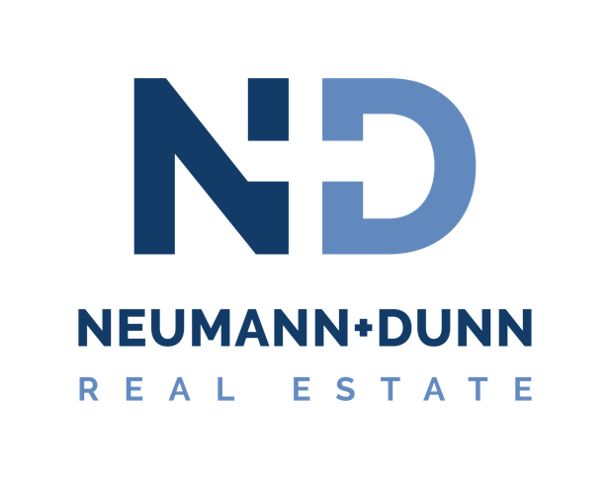

Congratulations of the purchase of your new home!

Below is an outline of actions required before closing. Please read this over and call or email me with any questions.

Closing Attorney – If you have a preferred real estate attorney or title company, please provide me the name and contact information. If you do not have a preference, we can offer suggestions. I will send the ratified agreement to the closing company as soon as possible to begin the settlement process. They will contact you regarding homeowners insurance, surveys and other pertinent information.

Loan – If not already done, please make formal loan application as soon as possible and provide me the contact information. I will forward the ratified Purchase Agreement to your lender if you would like. In addition to processing your application, the Lender will have the home appraised and provide you with the appraisal information.

Home Inspection – We will coordinate with you to set up the inspection within the time frame specified in the Purchase Agreement (pg 4 para 14). If possible, you should be present during the inspection. Afterward, I will receive the report, review each item with you, and help you determine what steps to take. If you choose to request repairs, an addendum will be prepared for your signature and then forwarded to the seller’s agent. There may be some negotiation required prior to an agreement between you and the seller.

Property/Homeowner’s Association (POA/HOA) Documents – Since this home is located in a community that is governed by a POA/HOA, you will be provided with a copy of these documents as soon after ratification of the Purchase Agreement as possible. You will have 3 days to review and determine if the information contained therein is acceptable to you.

Home Warranty – If the contract calls for a home warranty, we will order and a copy of the confirmation will be provided to you and your attorney.

Termite Inspection – The seller is responsible for the termite inspection within 30 days of closing. A copy of the report will be sent to your closing company.

Well/Septic Inspection – If applicable, the seller is responsible to perform a well and septic inspection within 30 days of closing. A copy of the report will be sent to your closing company.

______________________________________________________________________________
Neumann+ Dunn Real Estate and Development, LLC
Your name and phone number

Utilities – Enclosed is an information sheet with phone number for metro area service providers. You must contact the appropriate companies a week or two prior to closing and have them transfer service to your name, effective the date of closing.

Walk-through – You will take a final walk-through of the property, usually 24-48 hours prior to closing. At this time, you will confirm that repairs from the home inspection have been completed and check that all conditions have been met for settlement of the property.

Settlement (closing) – Your lender will provide your closing attorney with loan documents just prior to closing. We will review the closing statement for accuracy. Your closing attorney will provide you with the exact amount of the certified check you will need to bring with you to closing.

If you have any questions or concerns at any time during this process, please do not hesitate to contact me. I look forward to working with you.

______________________________________________________________________________
Neumann+ Dunn Real Estate and Development, LLC
Your name and phone number

